More than I Can say [C] Leo Sayer - The Crickets 1980 BPM: 96
Writers: Sonny Curtis, Jerry Allison https://www.youtube.com/watch?v=dGKnSdikqjw But in Bb

INTRO: ₁ ₂ ₃ ₄ ₁ GUITAR RIFF: Then [C] [C] [Am] [Am] [C] [C] [Am] [Am↓]

VERSE 1: -------------------------------------------------------------------------------------------------------------
[NC] Woah woah yea [C] yay~~, I love you more than I can [Am] say~~

[Am] - I love you twice as much to-[Em]morrow
Woah [Dm//] oah, love you [G//] more than I can [C] say [C↓]

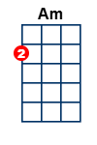
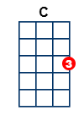
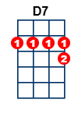
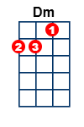
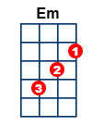
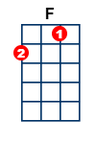
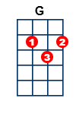
VERSE 2: ---------------------------------------------------------------------------------------------------------------------
[NC] Woah woah yea [C] yay~~,I miss you every single [Am] day
[Am] Why must my life be filled with so-[Em]rrow
Woah [Dm//] woah, love you [G//] more than I can [C] say

CHORUS 1: ------------------------------------------------------------------------------------------------------------------
[C] Don't you know I need you [F] so~~, Tell me please, I gotta [C] know~~
[C] Do you mean to make me [D7] cry~~,? Am I just another [G] guy? [G]

VERSE 3: ---------------------------------------------------------------------------------------------------------------------
Woah woah yea [C] yay~~, I miss you more than I can [Am] say~~~
[Am] Why must my life be filled with so-[Em]rrow
Woah [Dm//] woah, love you [G//] more than I can [C] say [C]

INSTRUMENTAL with OOOhh’s----------------------------------------------------------------------------------------
Woah woah yea [C] yay, I miss you [C] every single [Am] day
Why must [Am] my life be filled with so-[Em]rrow
Woah [Dm//] woah, love you [G//] more than I can [C] say

CHORUS 2: ------------------------------------------------------------------------------------------------------------------
[C] Don't you know I need you [F] so~~, Tell me please I gotta [C] know~~
[C] Do you mean to make me [D7] cry~~,? Am I just another [G] guy? [G]

VERSE 4: ---------------------------------------------------------------------------------------------------------------------
Woah woah yea [C] yay~~, I love you more than I can [Am] say ~~
[Am] I love you twice as much to-[Em]morrow
Woah [Dm//] oah, love you [G//] more than I can [C] say

[Dm//] I love you more [G//] than I can [C] say
[Dm//] I love you more [G//] than I can [C] ↑say~~

14 Aug 2026

