I Don't Want To Talk About It [C] Rod Stewart 1977 / 2019
Writer: Danny Whitten https://www.youtube.com/watch?v=esUHMBHJsn8 BPM: 85

= Repeat previous bar
INTRO: ₁ ₂ ₃ ₄ [Dm] [G] [C] [C]

VERSE 1: ---------------------------------------------------------------------------------------------------
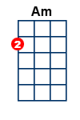
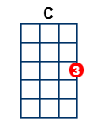
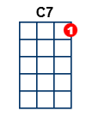
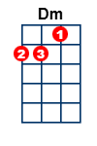
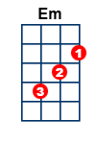
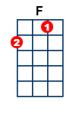
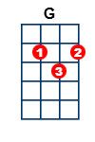
I can [Dm] tell by your eyes
That you've [G] probably been crying for [C] ever ₂ ₃ ₄
And the [Dm] stars in the sky
Don't mean [G] nothing, to you they're a [C] mirror [C7]

CHORUS 1: ---------------------------------------------------------------------------------------------------
[F] , ,I don't wanna [G] . . talk about it
[C] . . How you [Em] broke my [Am] heart
[F] . . If I stay here just a [G] . little bit longer
[F] . . If I stay here won't you [G\ ] listen [STOP]
[NC] To my [Dm] h e a r r t [G] . . . Oh my [C] heart ₂ ₃ ₄

VERSE 2: ---------------------------------------------------------------------------------------------------
If I [Dm] stand all alone
Will the [G] shadows hide the colours of my [C] heart
Blue, for the tears
Black, for the nights fears
The [Dm] stars in the sky
Don't mean [G] nothing, to you they're a [C] mirror [C7]

CHORUS 2: ---------------------------------------------------------------------------------------------------
[F] , ,I don't wanna [G] . . talk about it
[C] . . How you [Em] broke my [Am] heart
[F] . . If I stay here just a [G] . little bit longer
[F] . . If I stay here won't you [G\ ] listen [STOP]
[NC] To my [Dm] h e a r r t [G] . . . Oh my [C] heart ₂ ₃ ₄

INSTRUMENTAL VERSE 3: ---------------------------------------------------------------------------------------------------
[Dm] [G] [C] [C]
[Dm] [G] [C] [C7]

CHORUS 3: ---------------------------------------------------------------------------------------------------
[F] , ,I don't wanna [G] . . talk about it
[C] . . How you [Em] broke my [Am] heart
[F] . . If I stay here just a [G] . little bit longer
[F] . . If I stay here won't you [G\ ] listen [STOP]
[NC] To my [Dm] h e a r r t [G] . . . Oh my [C] heart
[C] - Oh to my [Dm] h e a r r t [G] . . . Oh my [C] heart [C \ ]

